Print PDF as an image
Problems can occur when you print a PDF file. For example, a PDF file can contain damaged content such as images or fonts that Acrobat cannot process during printing. Printing a PDF file as an image bypasses that processing by sending the printer a simple image of the document instead. This process can cause images and fonts to look slightly rougher, especially at the edges. However, you can specify the resolution in dots per inch (dpi) to suit your needs.

1. Ensure that your printer is turned on and connected.
If necessary, test print a different file.

2. Choose File > Print, and then click Advanced.
The location of the Advanced button depends on the version of Reader or Acrobat.
Mac OS: If you don't see the Advanced button, click the Down Arrow (to the right of the Printer pop-up menu).

3. Select Print As Image.
The location of the Print As Image options depends on the version of Reader or Acrobat.

Windows®
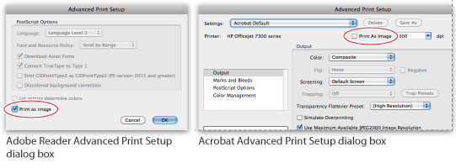

4. Click OK to close the Advanced Print Setup dialog box, and then click OK to print.

To the top

Other solutions
Tracking down printing issues can be difficult. The problems can range from a damaged font, to an older printer driver, to a bad sector on the disk. See the following articles and tips for additional solutions.

Install the latest update
Adobe releases free security updates quarterly. The updates often include improvements to common problems. Download the latest free update:
- Open Reader or Acrobat.
- Choose Help > Check For Updates. If a new update is available, it installs automatically.
- Once installed, restart you computer.
- Print the PDF again.

Reader 10.1.2
If you recently updated to Reader 10.1.2, see Printing questions | Acrobat, Reader 10.1.2 or later.

Acrobat 9.4.2
If you recently updated to Acrobat 9.4.2, see Printing problems | Acrobat 9.4.2 update.

Garbled text
If the text is garbled or prints with "junk" characters, print again, but keep the PDF open until the entire PDF prints. If you are printing from the web, try printing using a different browser. Again, keep the browser window open until the PDF has finished printing.

In-depth troubleshooting
See this troubleshooting article for additional solutions, such as updating your printer driver and copying the PDF file to your hard drive.

Search the forums
Forums have discussions about issues similar to yours. To participate in a community forum, type the description of your issue in the search box on the Acrobat or Adobe Reader forum. Or, post the question on the AcrobatUsers.com Printing & Prepress forum. When posting on forums, include your operating system and your product version number.

