To log into the helpdesk to log a problem click on staff links from our main home page

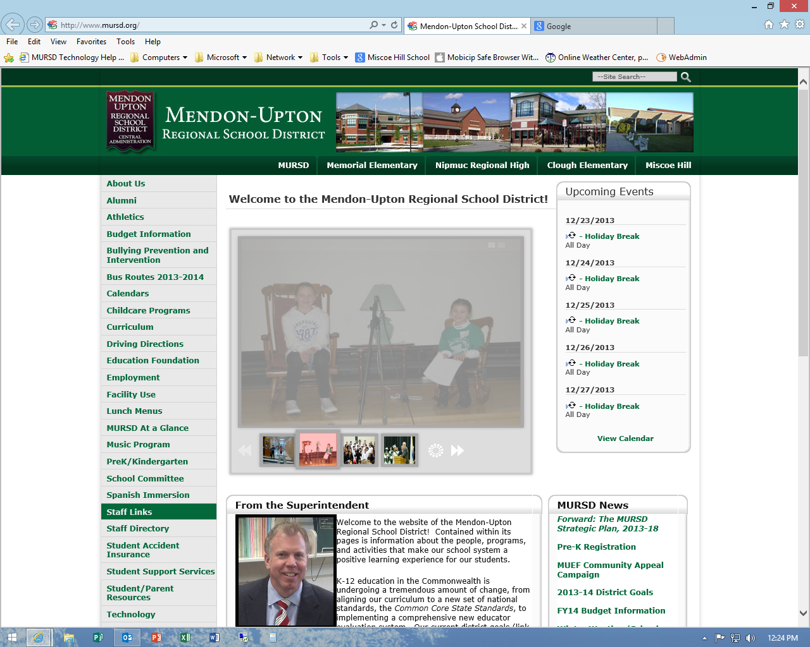

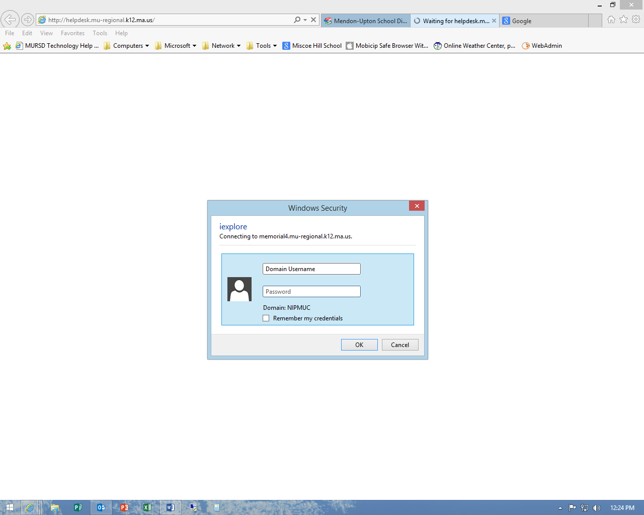

You will want to use the username you log into your computer \*\*NOT YOUR EMAIL address\*\*

Enter your domain password