DropBox (This is from Aime Hughes) A test
Step 1. Go to start and type in: \\nipmuc04
Go to Student Share and download DropBox
Step 2. It will ask you for administrative permission. You can say no and then yes it will install anyway.
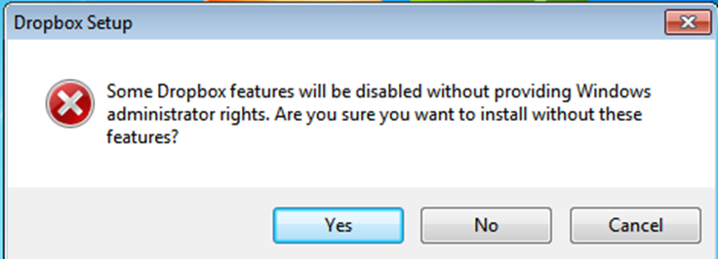
Step 3. It will ask you if you have an account if you don’t or would like to make a new account click Next.

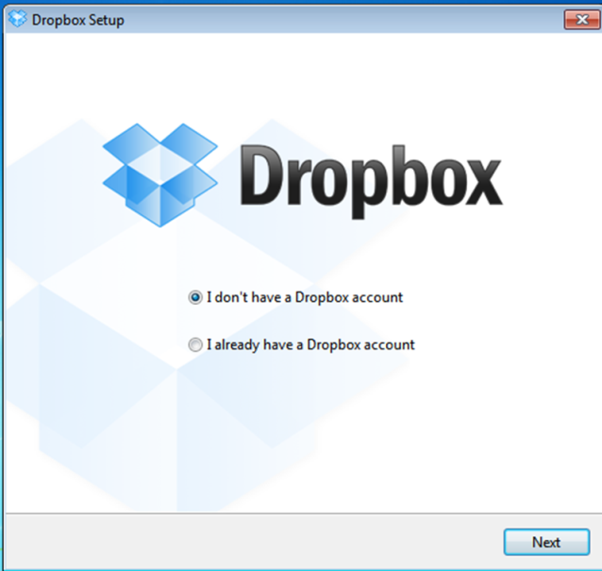

Step 4. Create your account

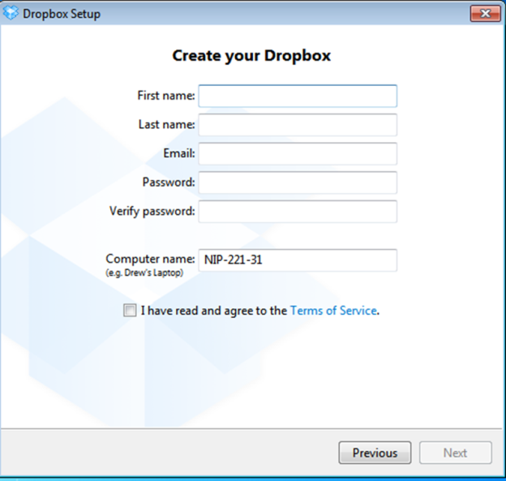

Step 5. Select your plan. 2 GB is free

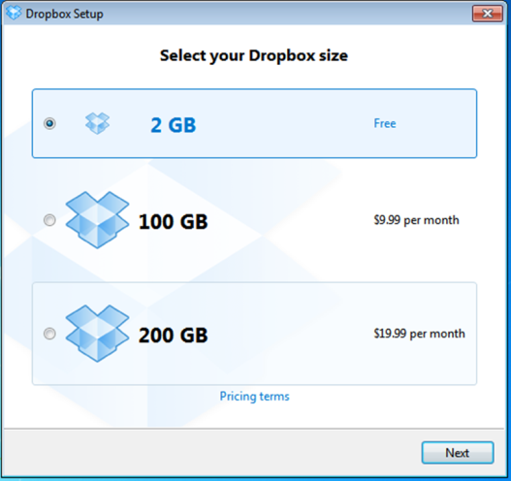

Step 6.Either one can be used once you have DropBox.

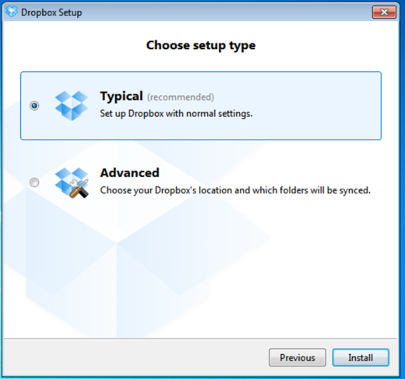
Step 7. Can be used to set up your smart phone

Step 8. Informational part of DropBox
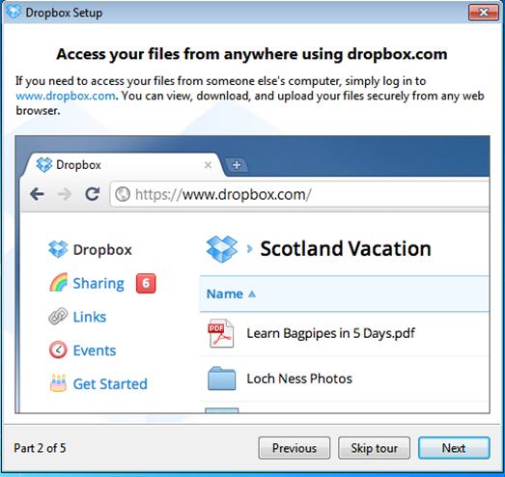
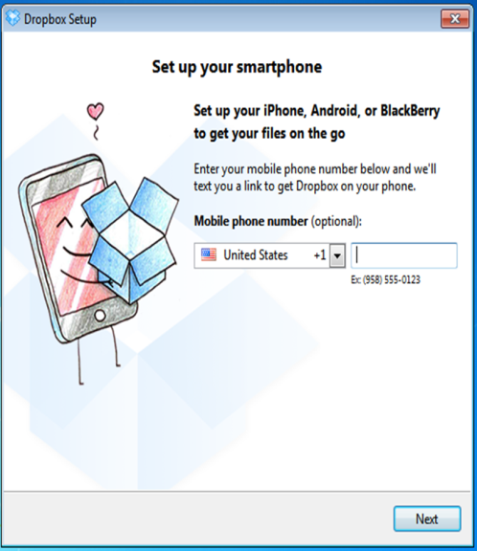
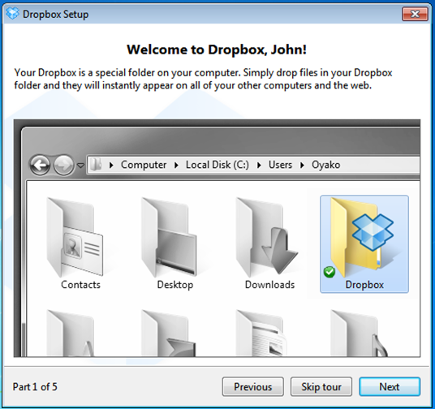

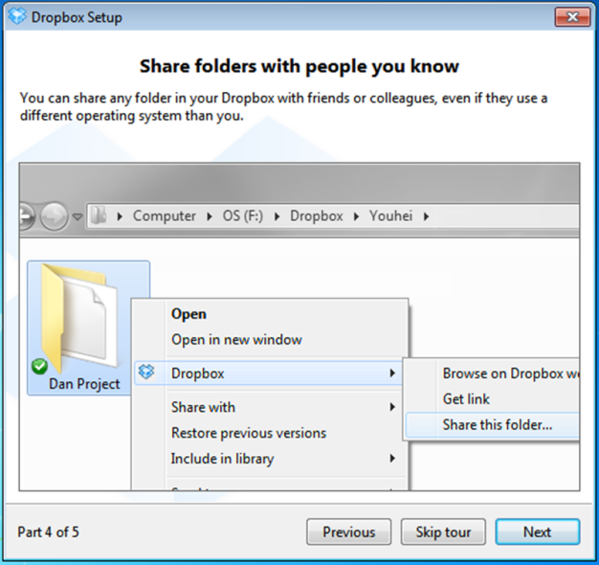
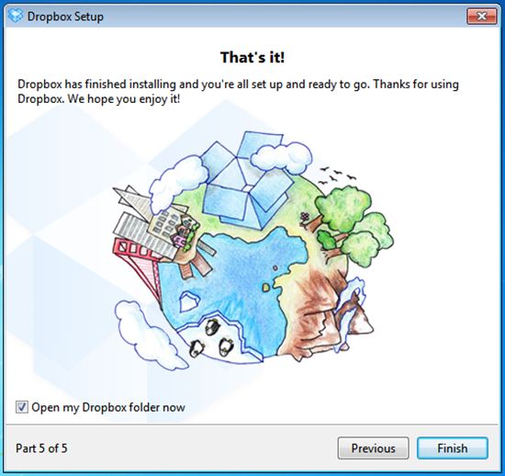

DropBox
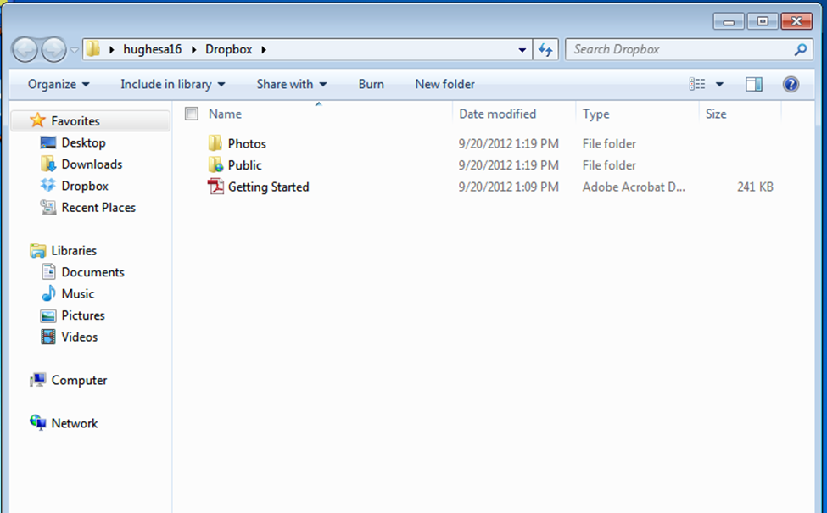

Sharing
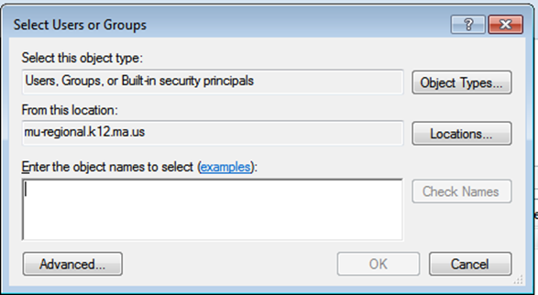
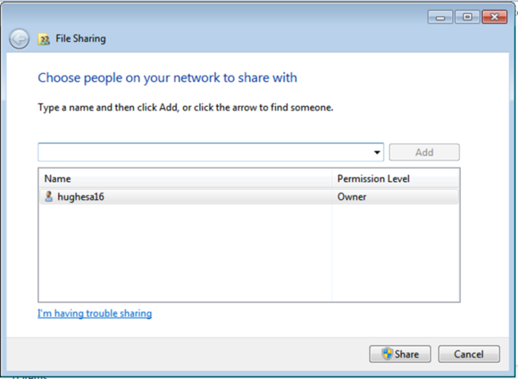
WWW.dropbox.com Put in Logon and password

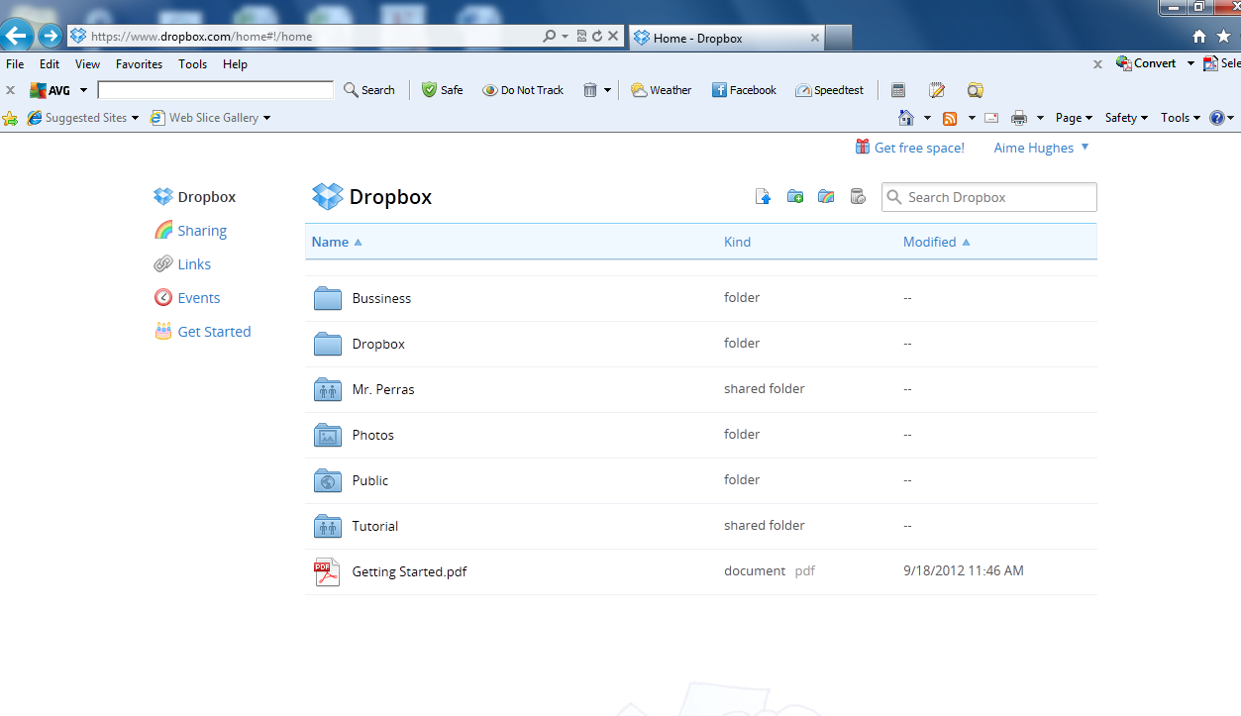

Sharing a Folder

Adding Folder
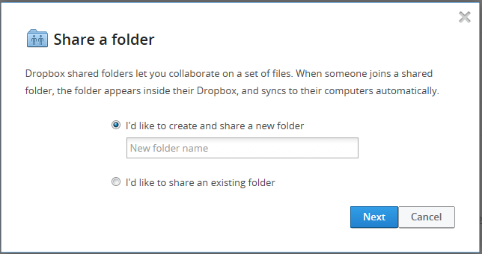
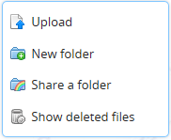
Right click on dropbox

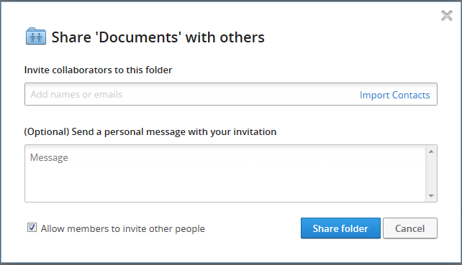
You will have to go to email to verify you email address. Open drop box email and click verify my email address and go back to DropBox.
Your friends will get an email to share this folder.
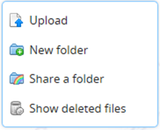
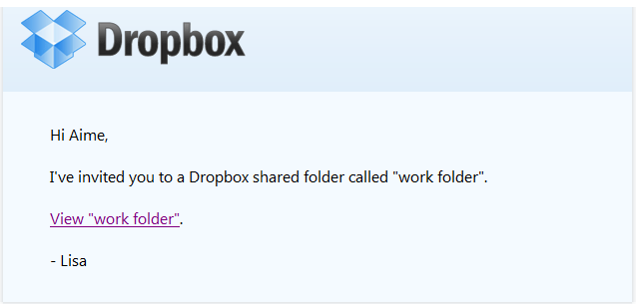

Making a folder to share.
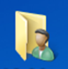
Teachers Name
Folder Not Shared

Nipmuc
All your classes are now represented in one Folder Students need to make folders with their names on them and period they take the class and share them with the teacher.
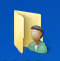
Student Name A
Shared Folder

Photos

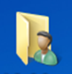
Teachers Name
Folder Not Shared

If you share the outside folder then everything inside is shared.
If you don’t share the outside folder you can share the inside folder. And only that folder is shared with the teacher
Student Name B
Shared Folder

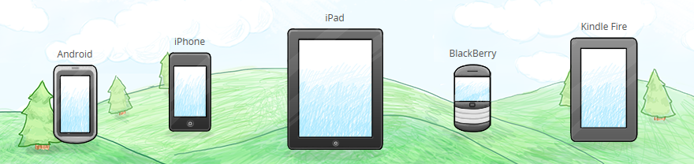

What can you put drop box on

Adding Files
Using Upload
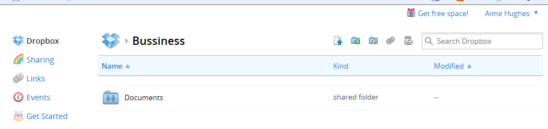
Upload

NEXT
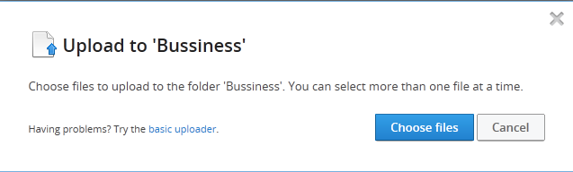

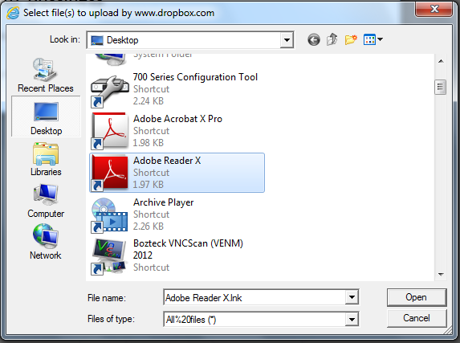

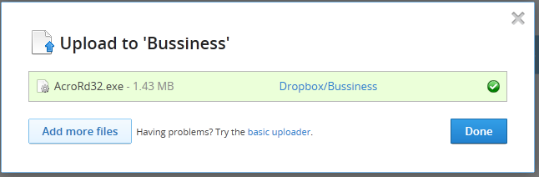

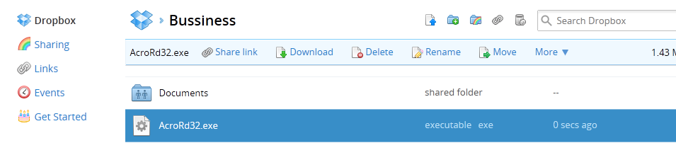

Settings
Under your name Settings:
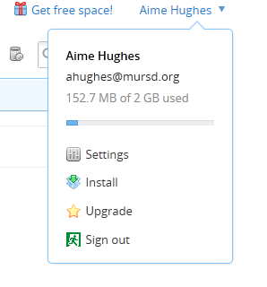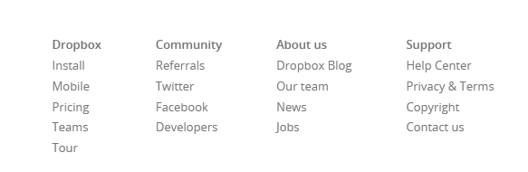
Referrals you can bring in contacts from your Gmail,Yahoo,AOL…
Make a distribution list of your students in your email and bring that list into DropBox and use it to send out assignments.
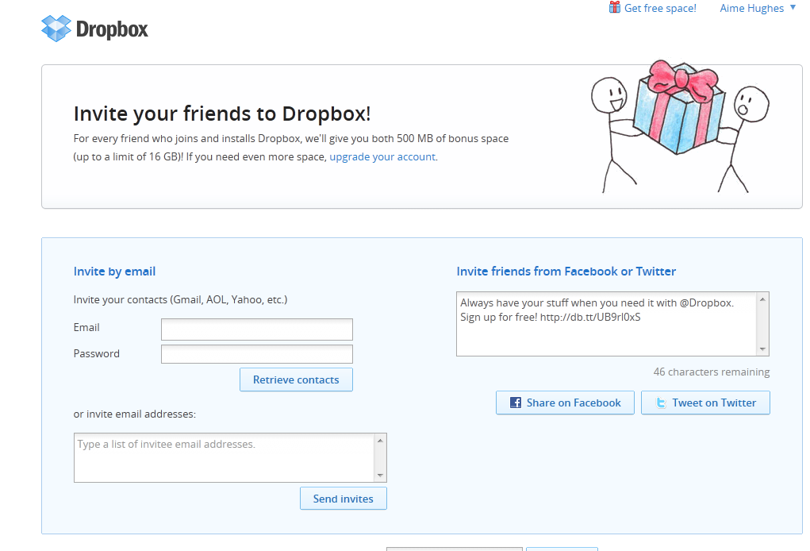
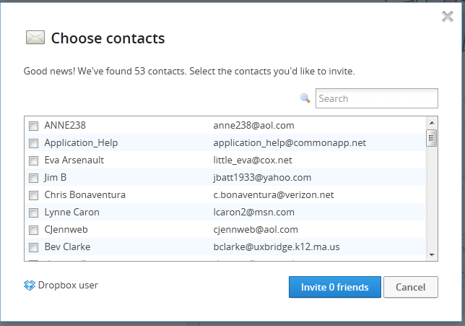

Some Interesting Apps for DropBox:
Type into your Browser: 10 best apps for DropBox
You will get plenty of hits.
10 Apps for DropBox: http://www.makeuseof.com/tag/10-apps-dropbox/
DropBox is expanding every day New Apps, new ways to use it and expand your cloud experience.

