Compatibility View Settings:
If you are having problems with a web page view properly try changing this setting:
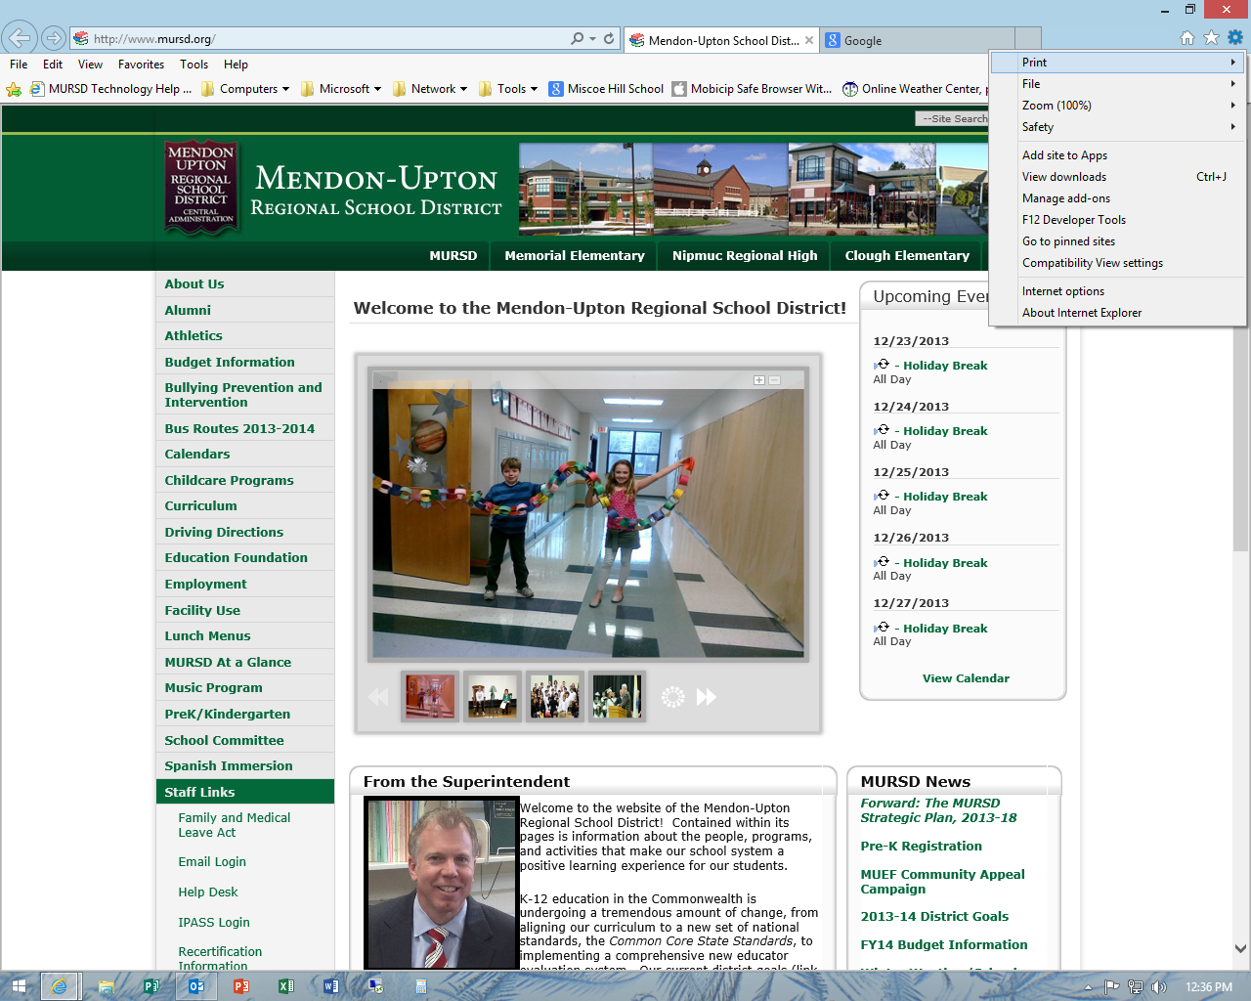
Choose compatibility view and add or remove website to the list
Left click on gear

