Open up Internet Explorer:

Internet Options
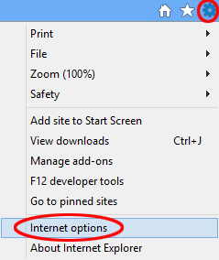
Click on the Gear icon, also known as the Action or Tools menu, located in the upper right hand corner of your browser window. When the drop-down menu appears, select Internet options (circled in the example above).
Home Page Options
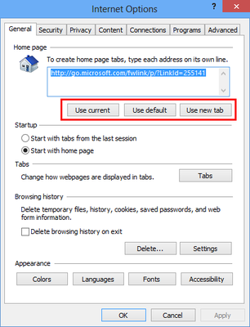
The Internet Options dialog should now be displayed. Click on the General tab if it is not already selected.
The top section in IE10's General options, labeled Home page, contains the following three buttons.
- Use current: Clicking on this button will set the home page value, highlighted in blue in the example above, to whatever Web page you are currently viewing.
- Use default: Clicking on this button will set the home page value to Microsoft's default URL, highlighted in blue in the example above.
- Use new tab: Clicking on this button will set the home page value to about:Tabs, which displays thumbnails of your most frequently visited websites as well as links that can reopen your last session or discover related websites that you may like.

Home Page Tabs
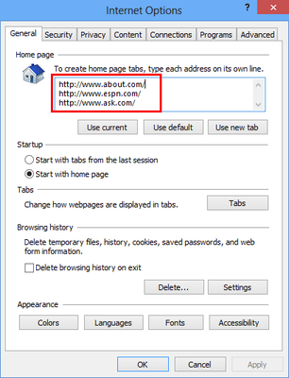
Upon hearing the term home page, it is common to think of a singular URL. IE10, however, lets you specify multiple addresses as your home page; each opening in its own respective tab.
To do this, simply enter each desired URL on its own line in the edit box provided. In the example above, I have set my home page tabs to About.com, ESPN, and Ask.com.
Startup Behavior
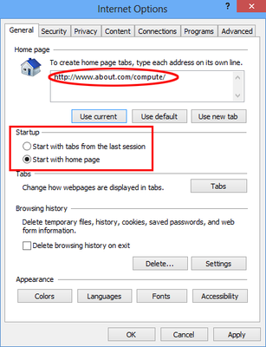
Directly below Home page in IE10's General options is the Startup section, which contains the following two choices; each accompanied by a radio button.
- Start with tabs from the last session: When selected, IE10 will relaunch all open tabs from your previous browsing session upon application startup.
- Start with home page: Selected by default, this option instructs IE10 to open your individual home page or home page tabs whenever the browser is launched.

